WEEK-2 JUnit_Basic Testing Exercises
Exercise 1:Setting Up JUnit

Pom.xml File
<project xmlns="http://maven.apache.org/POM/4.0.0" xmlns:xsi="http://www.w3.org/2001/XMLSchema-instance"
xsi:schemaLocation="http://maven.apache.org/POM/4.0.0 http://maven.apache.org/maven-v4_0_0.xsd">
<modelVersion>4.0.0</modelVersion>

<groupId>com.kiki.junitdemo</groupId>

<artifactId>JUnitDemo</artifactId>

<packaging>jar</packaging>

<version>1.0-SNAPSHOT</version>

<name>JUnitDemo</name>

<url>http://maven.apache.org</url>

<dependencies>
<dependency>
<groupId>junit</groupId>
<artifactId>junit</artifactId>
<version>4.13.2</version>
<scope>test</scope>
</dependency>
</dependencies>

</project>

AppTest.java
import org.junit.Test;
import static org.junit.Assert.*;
public class AppTest {
@Test
public void simpleAdditionTest() {
int result = 2 + 3;
assertEquals(5, result);
}
}
Output:
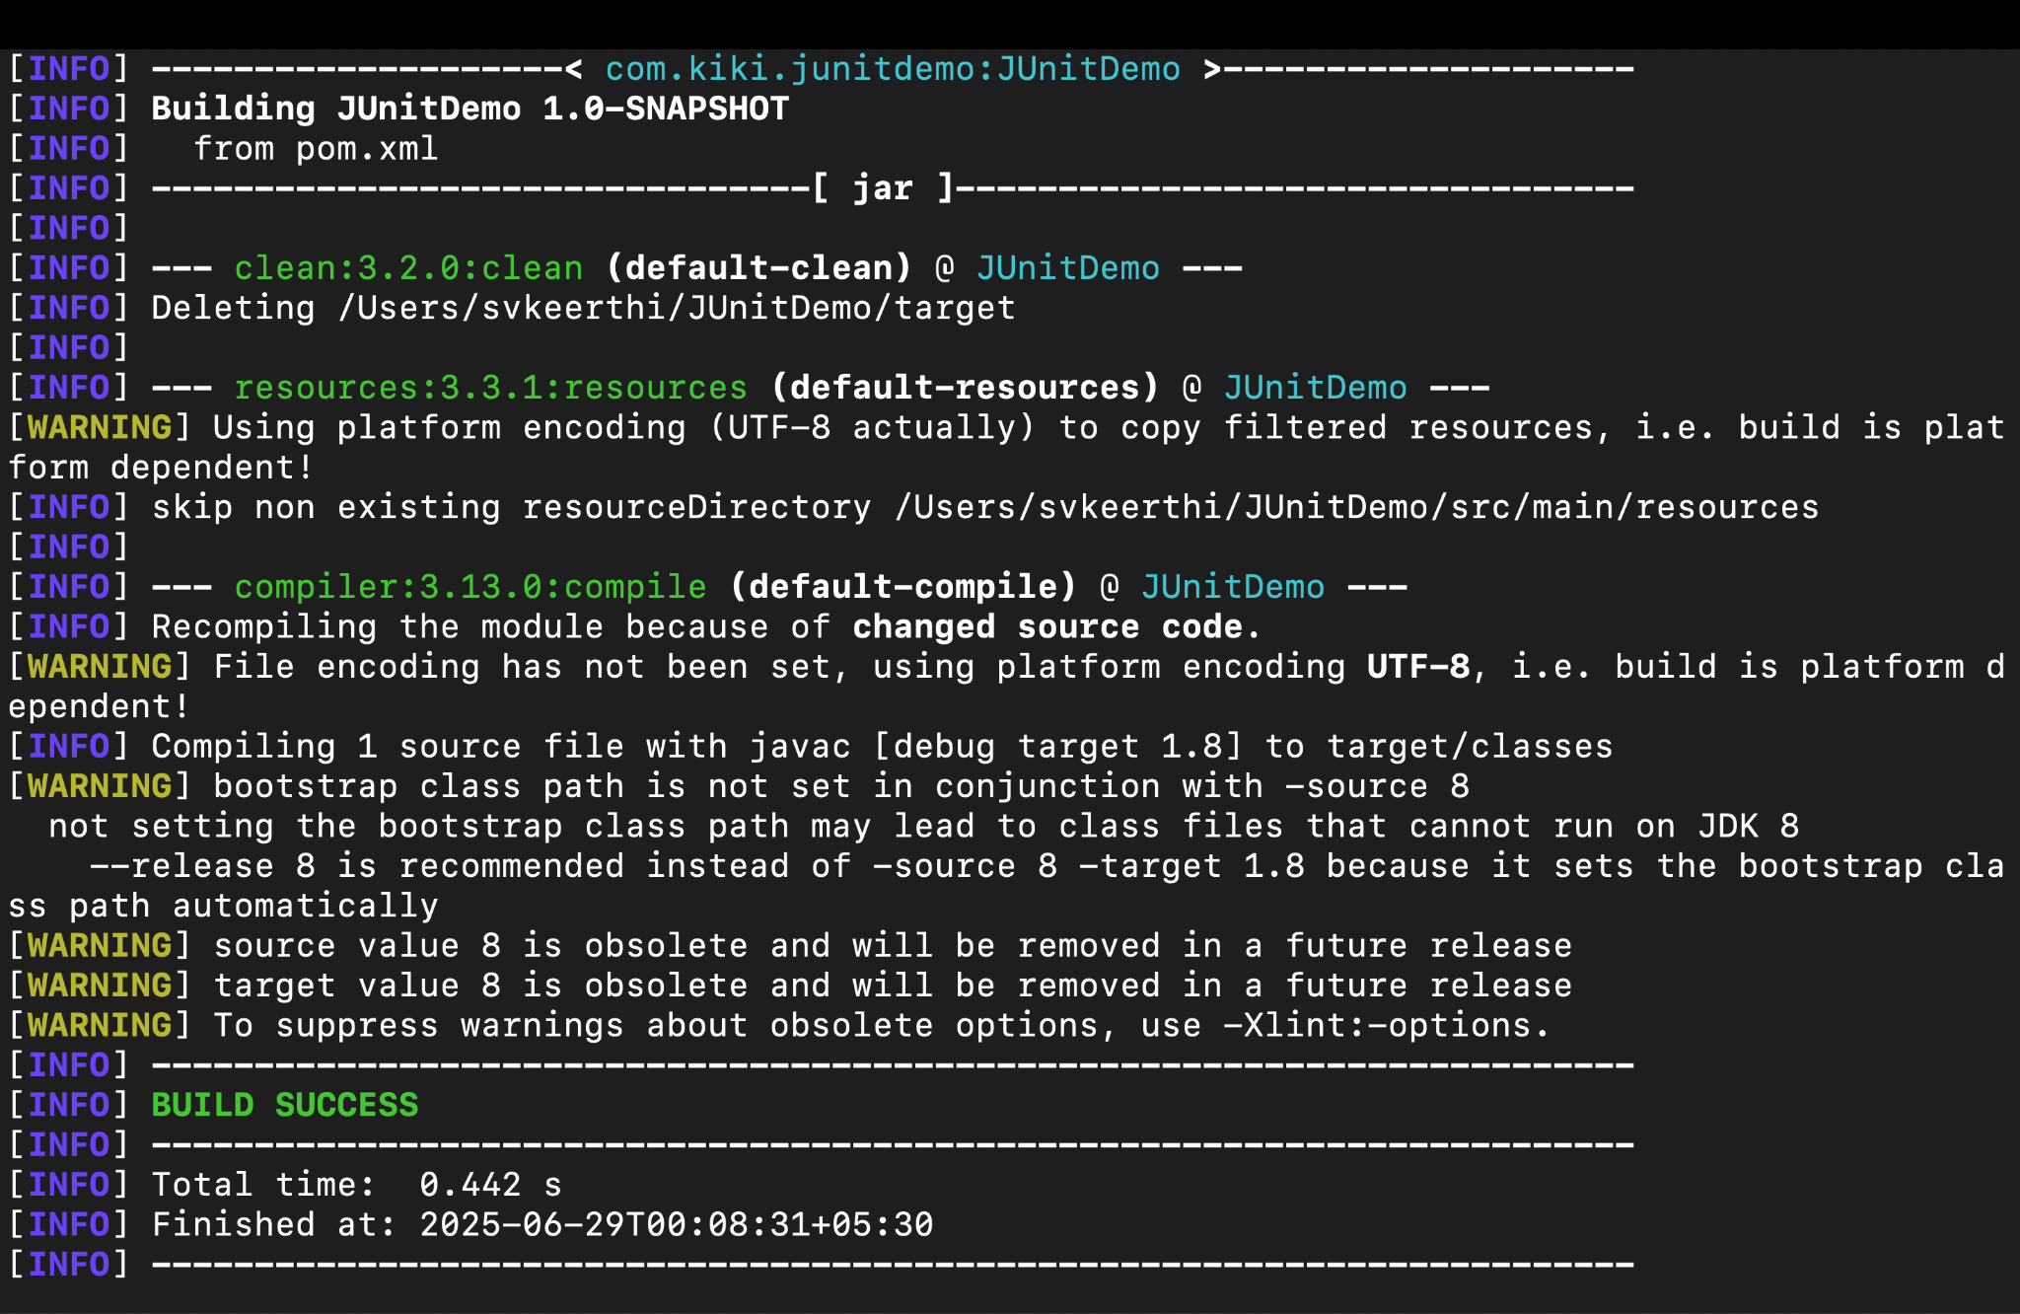
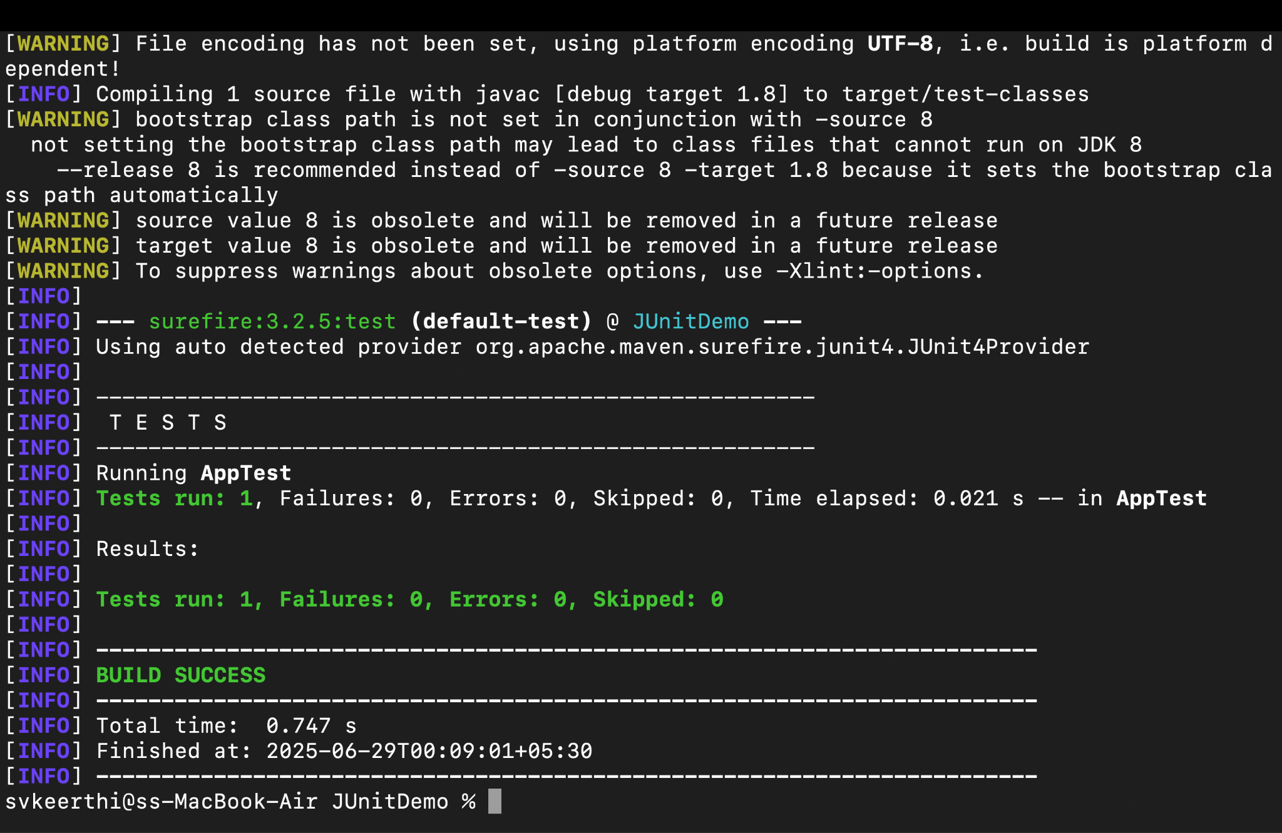

Exercise-3:Assertions in JUnit
package com.kiki.junitdemo;
import org.junit.Test;
import static org.junit.Assert.*;
public class AssertionsTest {
@Test
public void testAssertions() {

assertEquals(5, 2 + 3);

assertTrue(5 > 3);
assertFalse(5 < 3);

Object obj1 = null;
assertNull(obj1);

Object obj2 = new Object();
assertNotNull(obj2);
}
}
Output:
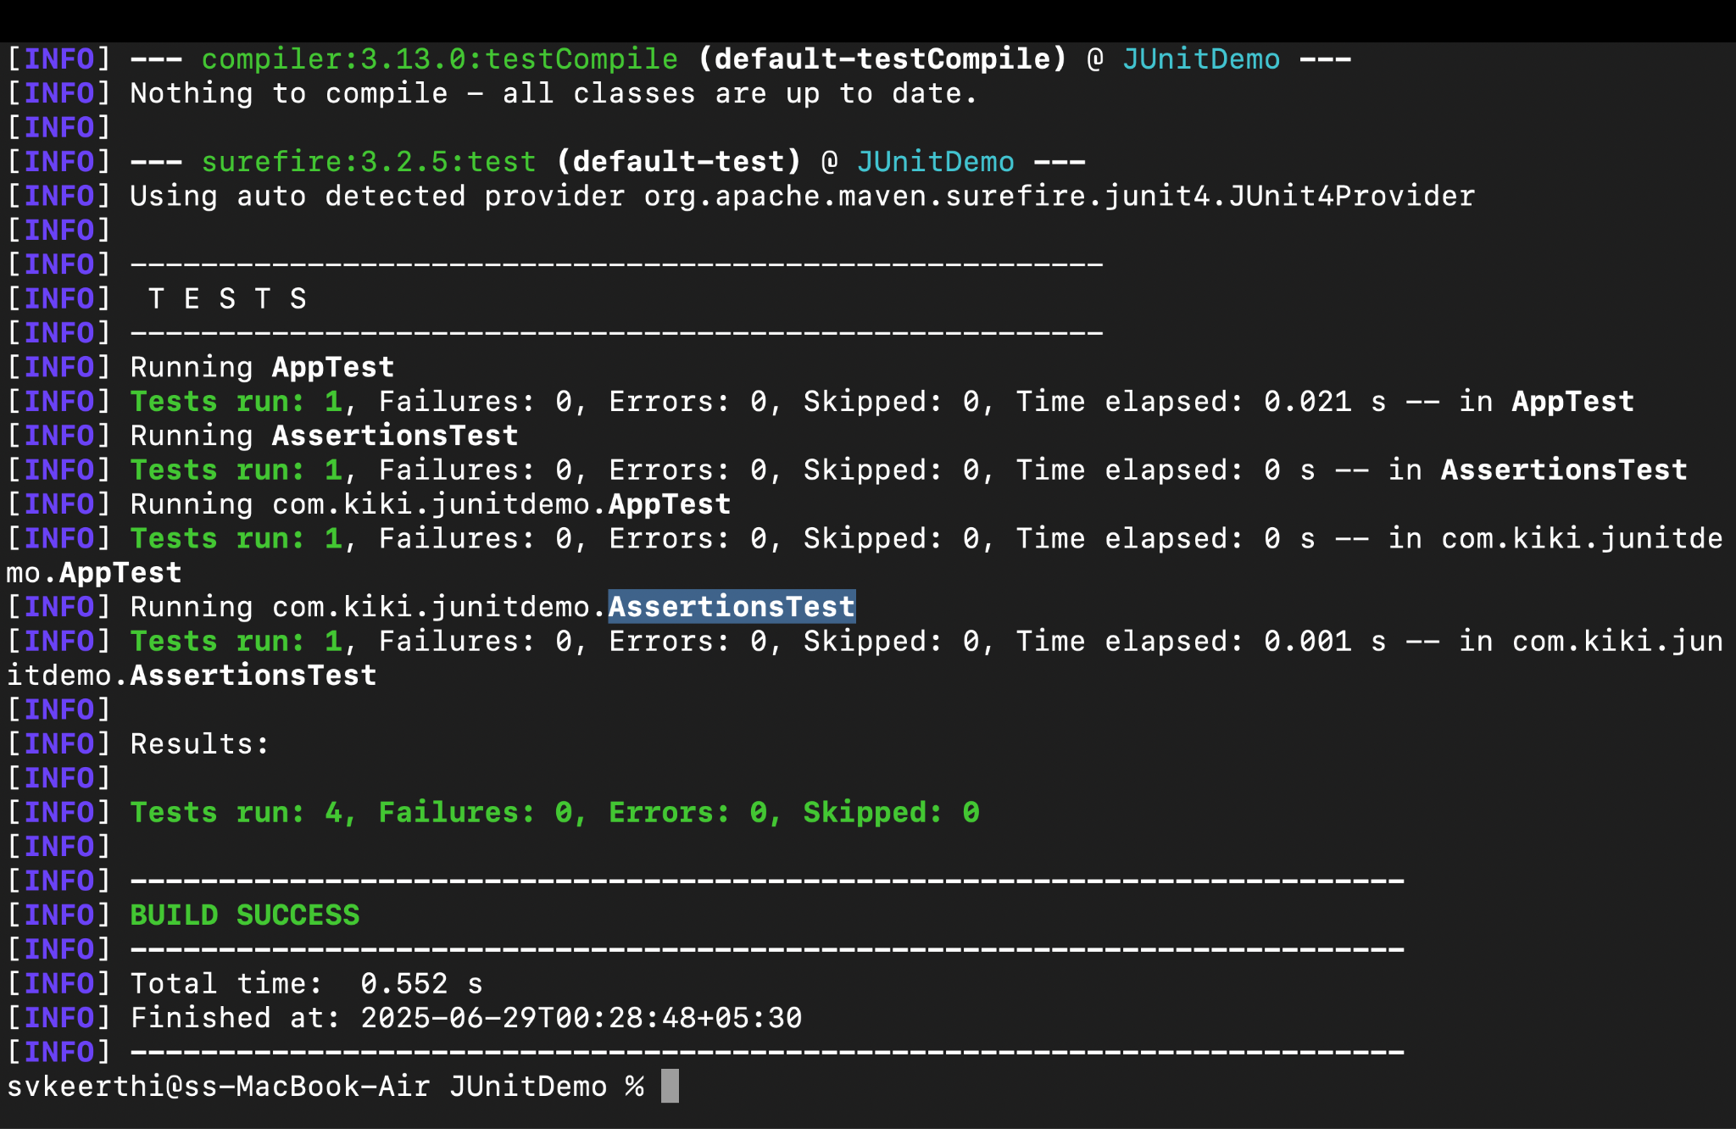

Exercise-4:AAA Pattern, Setup and Teardown Methods in JUnit

test/Calculator.java
package com.kiki.junitdemo;

import org.junit.Before;
import org.junit.After;
import org.junit.Test;
import static org.junit.Assert.*;

public class CalculatorTest {

private Calculator calc;

@Before
public void setUp() {
calc = new Calculator();
System.out.println("Setup complete.");
}

@After
public void tearDown() {
System.out.println("Test completed.\n");
}

@Test
public void testAddition() {
int result = calc.add(10, 5);
assertEquals(15, result);
}

@Test
public void testSubtraction() {
int result = calc.subtract(10, 3);
assertEquals(7, result);
}
}

Main/Calculator.java

package com.kiki.junitdemo;
public class Calculator {
public int add(int a, int b) {
return a + b;
}

public int subtract(int a, int b) {
return a - b;
}
}
Output:
